Architectural Components - Controller

📝Definition
# Source: AI Source: Provided by: [Data Path: Persons Table -> ID Column: 1, Name_En Column: Motasem Essam] -> From: [ChatGPT] on [1/23/2026]
The Controller is a component responsible for handling input from the user and coordinating the flow between View and Service/Model.
👉 Think of the Controller as the traffic director: it receives user actions, decides what to do, and sends results to the UI.

🔑 Responsibilities of Controller
# Source: AI Source: Provided by: [Data Path: Persons Table -> ID Column: 1, Name_En Column: Motasem Essam] -> From: [ChatGPT] on [1/23/2026]
- Receive input from the View/UI
- Call Service or Model to process data
- Decide what to show next in the View
- Keep minimal business logic (delegate to Service)

🧱 Example (MVC)
# Source: AI Source: Provided by: [Data Path: Persons Table -> ID Column: 1, Name_En Column: Motasem Essam] -> From: [ChatGPT] on [1/23/2026]
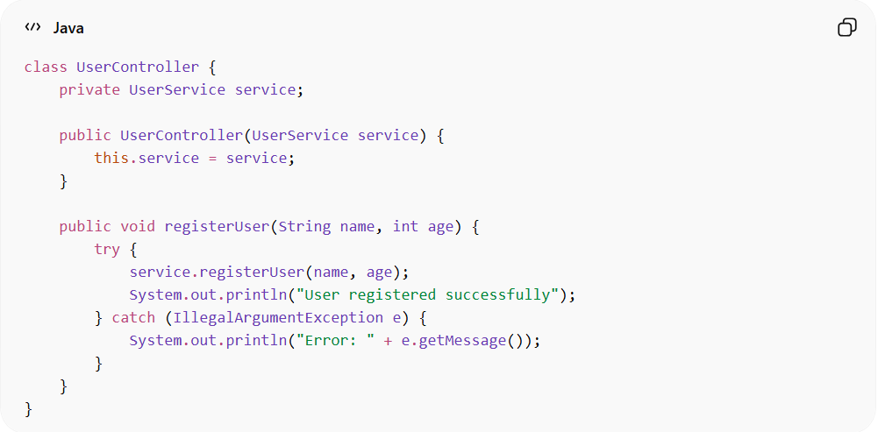
class UserController {
private UserService service;

public UserController(UserService service) {
this.service = service;
}

public void registerUser(String name, int age) {
try {
service.registerUser(name, age);
System.out.println("User registered successfully");
} catch (IllegalArgumentException e) {
System.out.println("Error: " + e.getMessage());
}
}
}
👉 Here:
- Controller receives user input
- Calls UserService for business logic
- Outputs result to the UI

❌ Bad Example (Controller Doing Too Much)
# Source: AI Source: Provided by: [Data Path: Persons Table -> ID Column: 1, Name_En Column: Motasem Essam] -> From: [ChatGPT] on [1/23/2026]
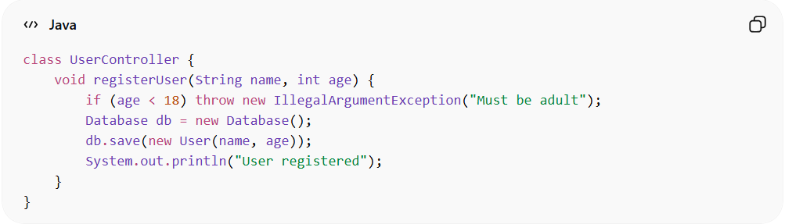
class UserController {
void registerUser(String name, int age) {
if (age < 18) throw new IllegalArgumentException("Must be adult");
Database db = new Database();
db.save(new User(name, age));
System.out.println("User registered");
}
}
👉 Problems:
- Handles business rules + DB access + UI output
- Violates Single Responsibility Principle (SRP)
- Hard to test

✅ Good Example (Thin Controller)
# Source: AI Source: Provided by: [Data Path: Persons Table -> ID Column: 1, Name_En Column: Motasem Essam] -> From: [ChatGPT] on [1/23/2026]
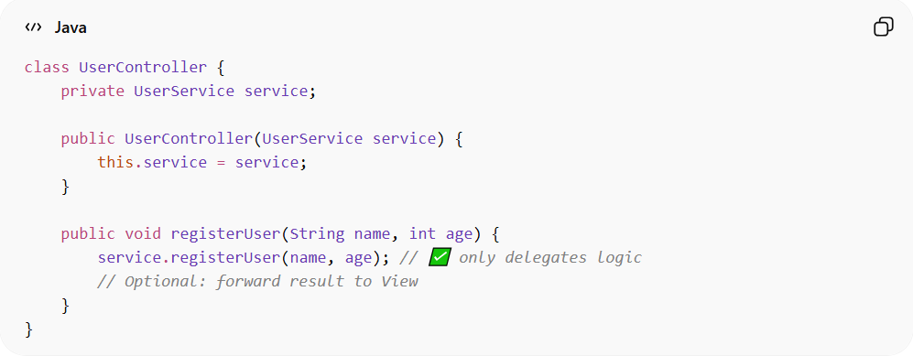
class UserController {
private UserService service;

public UserController(UserService service) {
this.service = service;
}

public void registerUser(String name, int age) {
service.registerUser(name, age); // ✅ only delegates logic
// Optional: forward result to View
}
}
👉 Benefits:
- Controller is thin
- Business logic lives in Service
- Easy to test independently

🕹️ Controller and APIs

1️⃣ Role of Controller
# Source: AI Source: Provided by: [Data Path: Persons Table -> ID Column: 1, Name_En Column: Motasem Essam] -> From: [ChatGPT] on [1/23/2026]
The Controller’s main job is to handle input and coordinate actions.
- In a web app / API context, the input usually comes as HTTP requests (GET, POST, PUT, DELETE).
- The Controller receives the request, calls Service/Business logic, and returns a response (JSON, XML, HTML).
Essentially: Controller acts as the interface between the client (API consumer) and your backend logic.

2️⃣ Example: API Controller in Java (Spring Boot)
# Source: AI Source: Provided by: [Data Path: Persons Table -> ID Column: 1, Name_En Column: Motasem Essam] -> From: [ChatGPT] on [1/23/2026]
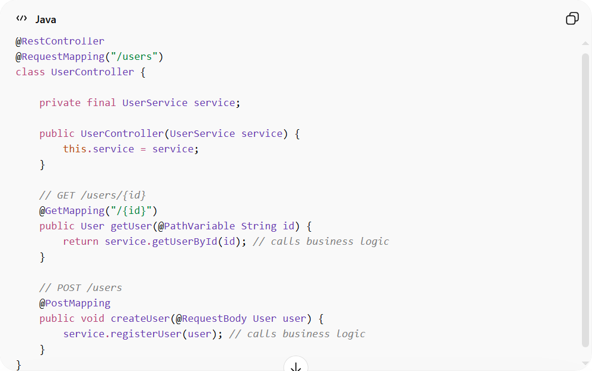
@RestController
@RequestMapping("/users")
class UserController {

private final UserService service;

public UserController(UserService service) {
this.service = service;
}

// GET /users/{id}
@GetMapping("/{id}")
public User getUser(@PathVariable String id) {
return service.getUserById(id); // calls business logic
}

// POST /users
@PostMapping
public void createUser(@RequestBody User user) {
service.registerUser(user); // calls business logic
}
}
✅ Here:
- Controller handles HTTP input/output
- Delegates business logic to Service
- Returns response to API consumer

3️⃣ API vs MVC Controller
# Source: AI Source: Provided by: [Data Path: Persons Table -> ID Column: 1, Name_En Column: Motasem Essam] -> From: [ChatGPT] on [1/23/2026]
- API Controller: Returns data (JSON, XML) → mostly stateless
- MVC Controller (Web UI): Returns views/templates (HTML) → interacts with View
Both are Controllers, but the type of “View” changes.

4️⃣ Key Principles
# Source: AI Source: Provided by: [Data Path: Persons Table -> ID Column: 1, Name_En Column: Motasem Essam] -> From: [ChatGPT] on [1/23/2026]
- Controller should not contain business logic
- Controller does not access DB directly → use Repository / Service
- Controller can be used for APIs or UI depending on pattern

5️⃣ Common Mistakes
# Source: AI Source: Provided by: [Data Path: Persons Table -> ID Column: 1, Name_En Column: Motasem Essam] -> From: [ChatGPT] on [1/23/2026]
❌ Mixing business logic in Controller
❌ Accessing DB or external APIs directly in Controller
❌ Returning raw domain objects without mapping (for APIs)

💡 Summary
# Source: AI Source: Provided by: [Data Path: Persons Table -> ID Column: 1, Name_En Column: Motasem Essam] -> From: [ChatGPT] on [1/23/2026]
- Controller = bridge between client (API/UI) and backend logic
- APIs are a natural use case for Controllers
- Controller delegates logic to Service, which may use Repository/Model

🌐 API Controller
# Source: AI Source: Provided by: [Data Path: Persons Table -> ID Column: 1, Name_En Column: Motasem Essam] -> From: [ChatGPT] on [1/23/2026]
An API Controller is a specialized type of Controller used in web services or RESTful APIs. It handles HTTP requests, delegates business logic to Services, and returns structured responses (usually JSON or XML) to clients.
👉 Think of it as the entry point for API clients like web apps, mobile apps, or other services.

🔑 Responsibilities of API Controller
# Source: AI Source: Provided by: [Data Path: Persons Table -> ID Column: 1, Name_En Column: Motasem Essam] -> From: [ChatGPT] on [1/23/2026]
- Receive HTTP requests (GET, POST, PUT, DELETE)
- Call Service or business logic layer
- Return responses with proper status codes
- Handle request validation and errors
- Keep the controller thin (no business logic inside)

🧱 Example: REST API Controller (Java + Spring Boot)
# Source: AI Source: Provided by: [Data Path: Persons Table -> ID Column: 1, Name_En Column: Motasem Essam] -> From: [ChatGPT] on [1/23/2026]
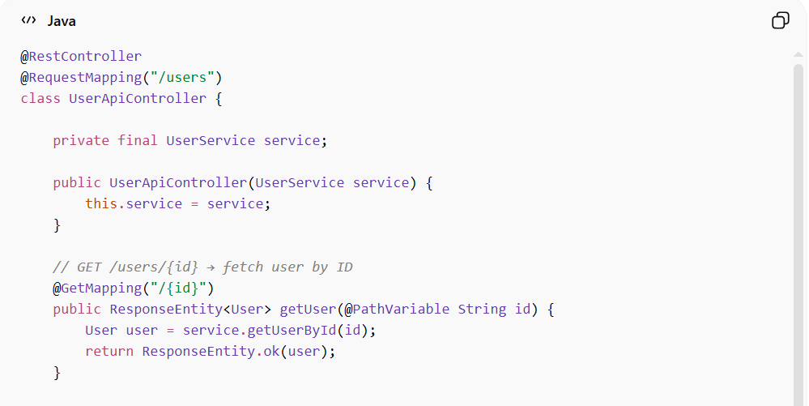
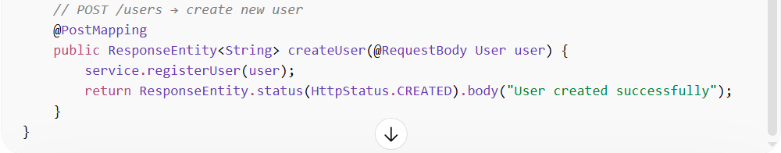
@RestController
@RequestMapping("/users")
class UserApiController {

private final UserService service;

public UserApiController(UserService service) {
this.service = service;
}

// GET /users/{id} → fetch user by ID
@GetMapping("/{id}")
public ResponseEntity<User> getUser(@PathVariable String id) {
User user = service.getUserById(id);
return ResponseEntity.ok(user);
}

// POST /users → create new user
@PostMapping
public ResponseEntity<String> createUser(@RequestBody User user) {
service.registerUser(user);
return ResponseEntity.status(HttpStatus.CREATED).body("User created successfully");
}
}

❌ Bad Example (API Controller with Business Logic)
# Source: AI Source: Provided by: [Data Path: Persons Table -> ID Column: 1, Name_En Column: Motasem Essam] -> From: [ChatGPT] on [1/23/2026]
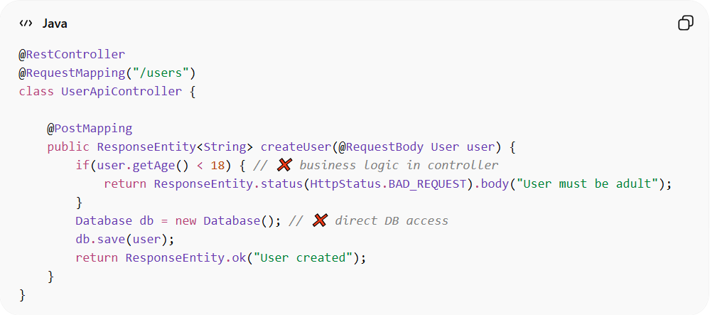
@RestController
@RequestMapping("/users")
class UserApiController {

@PostMapping
public ResponseEntity<String> createUser(@RequestBody User user) {
if(user.getAge() < 18) { // ❌ business logic in controller
return ResponseEntity.status(HttpStatus.BAD_REQUEST).body("User must be adult");
}
Database db = new Database(); // ❌ direct DB access
db.save(user);
return ResponseEntity.ok("User created");
}
}
Problems:
- Business rules in controller
- Direct database access
- Hard to test or maintain

✅ Good Practices
# Source: AI Source: Provided by: [Data Path: Persons Table -> ID Column: 1, Name_En Column: Motasem Essam] -> From: [ChatGPT] on [1/23/2026]
- Controller only delegates tasks to Service
- Handle HTTP-related concerns (status codes, headers, validation)
- Keep it stateless for scalability
- Map internal domain objects to DTOs for API responses

🔄 Relation to MVC / MVVM
# Source: AI Source: Provided by: [Data Path: Persons Table -> ID Column: 1, Name_En Column: Motasem Essam] -> From: [ChatGPT] on [1/23/2026]
- MVC: Controller coordinates Model & View
- API Controller: Controller coordinates Model & Service → returns data (JSON/XML) instead of UI
- MVVM: ViewModel replaces Controller for UI apps, but API Controllers still handle backend endpoints

💡 Key Idea
# Source: AI Source: Provided by: [Data Path: Persons Table -> ID Column: 1, Name_En Column: Motasem Essam] -> From: [ChatGPT] on [1/23/2026]
API Controller = gateway for clients → receives requests, delegates to Service, returns structured responses.

🧾 Summary
# Source: AI Source: Provided by: [Data Path: Persons Table -> ID Column: 1, Name_En Column: Motasem Essam] -> From: [ChatGPT] on [1/23/2026]
- Handles HTTP requests/responses
- Delegates business logic to Service
- Does not access DB directly
- Stateless and testable

🕹️ MVC Controller
# Source: AI Source: Provided by: [Data Path: Persons Table -> ID Column: 1, Name_En Column: Motasem Essam] -> From: [ChatGPT] on [1/23/2026]
In the MVC (Model-View-Controller) pattern, the Controller is the component responsible for handling user input and coordinating between the View and the Model.
👉 Think of the MVC Controller as the traffic director: it receives user actions, calls the appropriate business logic, and updates the View.

🔑 Responsibilities of MVC Controller
# Source: AI Source: Provided by: [Data Path: Persons Table -> ID Column: 1, Name_En Column: Motasem Essam] -> From: [ChatGPT] on [1/23/2026]
- Receive input from the user interface (View)
- Call Model or Service to perform actions
- Update the View with results
- Keep business logic out of the Controller

🧱 Example: MVC Controller (Java)
# Source: AI Source: Provided by: [Data Path: Persons Table -> ID Column: 1, Name_En Column: Motasem Essam] -> From: [ChatGPT] on [1/23/2026]
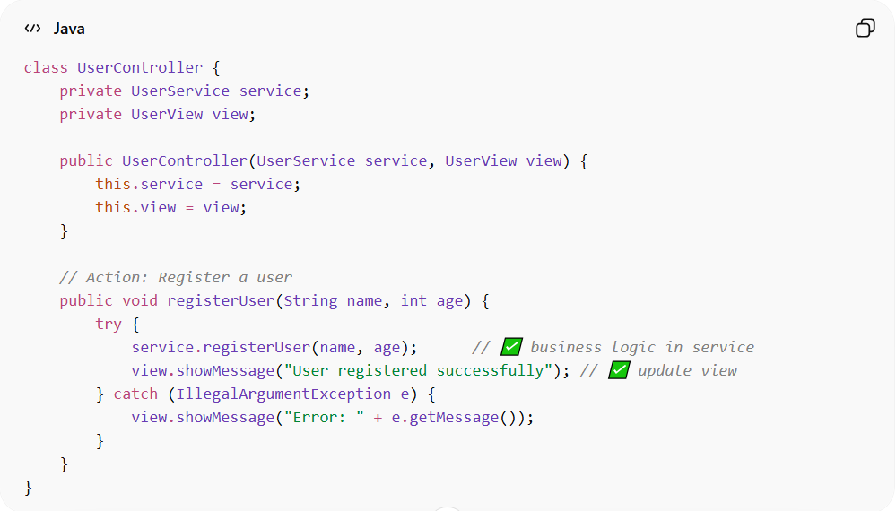
class UserController {
private UserService service;
private UserView view;

public UserController(UserService service, UserView view) {
this.service = service;
this.view = view;
}

// Action: Register a user
public void registerUser(String name, int age) {
try {
service.registerUser(name, age); // ✅ business logic in service
view.showMessage("User registered successfully"); // ✅ update view
} catch (IllegalArgumentException e) {
view.showMessage("Error: " + e.getMessage());
}
}
}
👉 Here:
- Controller receives input from View
- Delegates logic to Service/Model
- Updates View based on results

❌ Bad Example (Controller Doing Too Much)
# Source: AI Source: Provided by: [Data Path: Persons Table -> ID Column: 1, Name_En Column: Motasem Essam] -> From: [ChatGPT] on [1/23/2026]
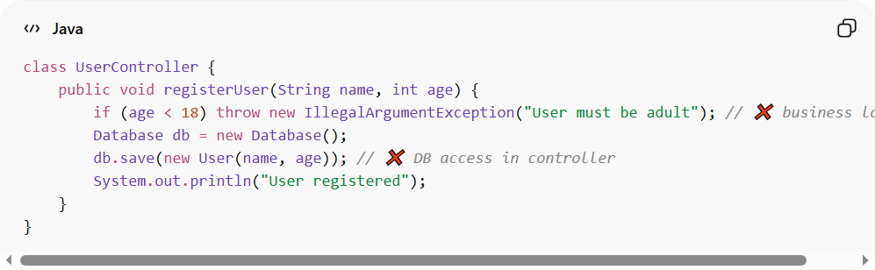
class UserController {
public void registerUser(String name, int age) {
if (age < 18) throw new IllegalArgumentException("User must be adult"); // ❌ business logic
Database db = new Database();
db.save(new User(name, age)); // ❌ DB access in controller
System.out.println("User registered");
}
}
Problems:
- Handles business rules
- Accesses database directly
- Updates UI/output directly
- Violates Single Responsibility Principle (SRP)

✅ Good Practices
# Source: AI Source: Provided by: [Data Path: Persons Table -> ID Column: 1, Name_En Column: Motasem Essam] -> From: [ChatGPT] on [1/23/2026]
- Controller is thin: only coordinates between View and Service
- Delegates logic to Service or Model
- Handles user input validation (optional)
- Keeps UI-independent logic outside

🔄 MVC Controller vs API Controller
# Source: AI Source: Provided by: [Data Path: Persons Table -> ID Column: 1, Name_En Column: Motasem Essam] -> From: [ChatGPT] on [1/23/2026]
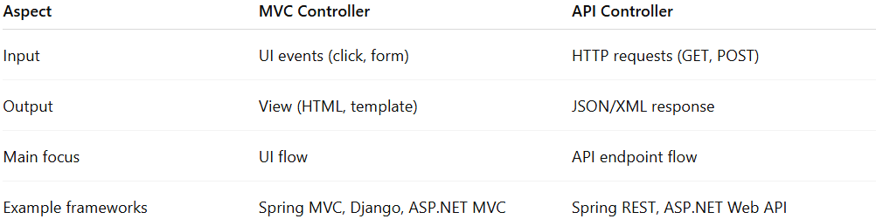
Aspect | MVC Controller | API Controller
Input | UI events (click, form) | HTTP requests (GET, POST)
Output | View (HTML, template) | JSON/XML response
Main focus | UI flow | API endpoint flow
Example frameworks | Spring MVC, Django, ASP.NET MVC | Spring REST, ASP.NET Web API
Both are Controllers, but MVC Controller is tied to the UI, whereas API Controller serves data clients.

💡 Key Idea
# Source: AI Source: Provided by: [Data Path: Persons Table -> ID Column: 1, Name_En Column: Motasem Essam] -> From: [ChatGPT] on [1/23/2026]
In MVC, the Controller connects the View and the Model, orchestrates logic through Services, and keeps the system organized, testable, and maintainable.

🧾 Summary
# Source: AI Source: Provided by: [Data Path: Persons Table -> ID Column: 1, Name_En Column: Motasem Essam] -> From: [ChatGPT] on [1/23/2026]
- Receives input from View
- Delegates business logic to Service/Model
- Updates View with results
- Keeps Controller thin and testable

🔄 Controller in Different Patterns
# Source: AI Source: Provided by: [Data Path: Persons Table -> ID Column: 1, Name_En Column: Motasem Essam] -> From: [ChatGPT] on [1/23/2026]
- MVC → Directly interacts with View and Service
- MVVM → Often replaced by ViewModel, but Controller may still exist for routing or input handling
- Clean Architecture → Controller is part of the interface layer, orchestrates use cases

⚠️ Common Mistakes
# Source: AI Source: Provided by: [Data Path: Persons Table -> ID Column: 1, Name_En Column: Motasem Essam] -> From: [ChatGPT] on [1/23/2026]
- Putting business rules in Controller ❌
- Accessing database directly ❌
- Mixing UI formatting in Controller ❌

💡 Key Idea
# Source: AI Source: Provided by: [Data Path: Persons Table -> ID Column: 1, Name_En Column: Motasem Essam] -> From: [ChatGPT] on [1/23/2026]
Controller handles input and flow, but never owns business rules or data storage.

🧾 Summary
# Source: AI Source: Provided by: [Data Path: Persons Table -> ID Column: 1, Name_En Column: Motasem Essam] -> From: [ChatGPT] on [1/23/2026]
Controller:
- Receives input from the user
- Calls Service/Model to perform actions
- Updates the View/UI
- Keeps the application clean and testable

